Revised 10/2015
Receipt #_________
Delivered_________
Photo or Image Print Special Order

Name_____________________________________________________________________________________________
Address____________________________________________________________________________________________
City/State/Zip____________________________________Phone______________________________________________
Email______________________________________________________________________________________________
Use of prints________________________________________________________________________________________

Size (in inches)
5X7
8X10
11X14
12X16
16X20
20X24
20X30
Price(for gloss paper)
10.00
15.00
30.00
40.00
80.00
120.00
150.00

The requested photos or images to be printed may only be for personal use and can in no way be scanned, copied, printed, forwarded, photographed or reproduced after the special order has been received. Orders must be paid for in full in advance, sales tax applies and if needed shipping charges will be added. Custom sizes and applications are available and special pricing will apply. Anything that needs to be scanned at a higher resolution than original size at 600 dpi will be an additional charge of $25 per hour; estimates will be given prior to the work being done and must be paid up front.

I, _______________________________________________________________________________on _______________ agree to the above terms and conditions and will receive the photo/image stated on the worksheet for personal use in the following format: original color___ black and white ___ sepia ___ other___ full bleed__ border__ cropping OK__
Special instructions or requests: ________________________________________________________________________
__________________________________________________________________________________________________

__________________________________________________
Smith County Historical Society representative has gone over the terms of this order with the guest.
__________________________________________________
Date
Photo/Image Print Special Order WORKSHEET
Print File Name: ___ _________________________________Timeline:_________________________________________
Object ID (word and number) | Description (limited what of) | B and W Sepia/Original (final color) | Print Size (5x7, 8x10, 11x17, etc.) | Found in (file, newspaper, book, etc.) | Printer Used (in house or contract) | Scanned (when and who)
Notes:___________________________________________________________________________________________________________________________________________________________________________________________________________________________________________________________________________________________________________________________________________________________________________________________________________________________________________________________________________________________________________________________________________________________________________________________________________________________________________________________________________________________________________________________________________________________________________________________________________
Our
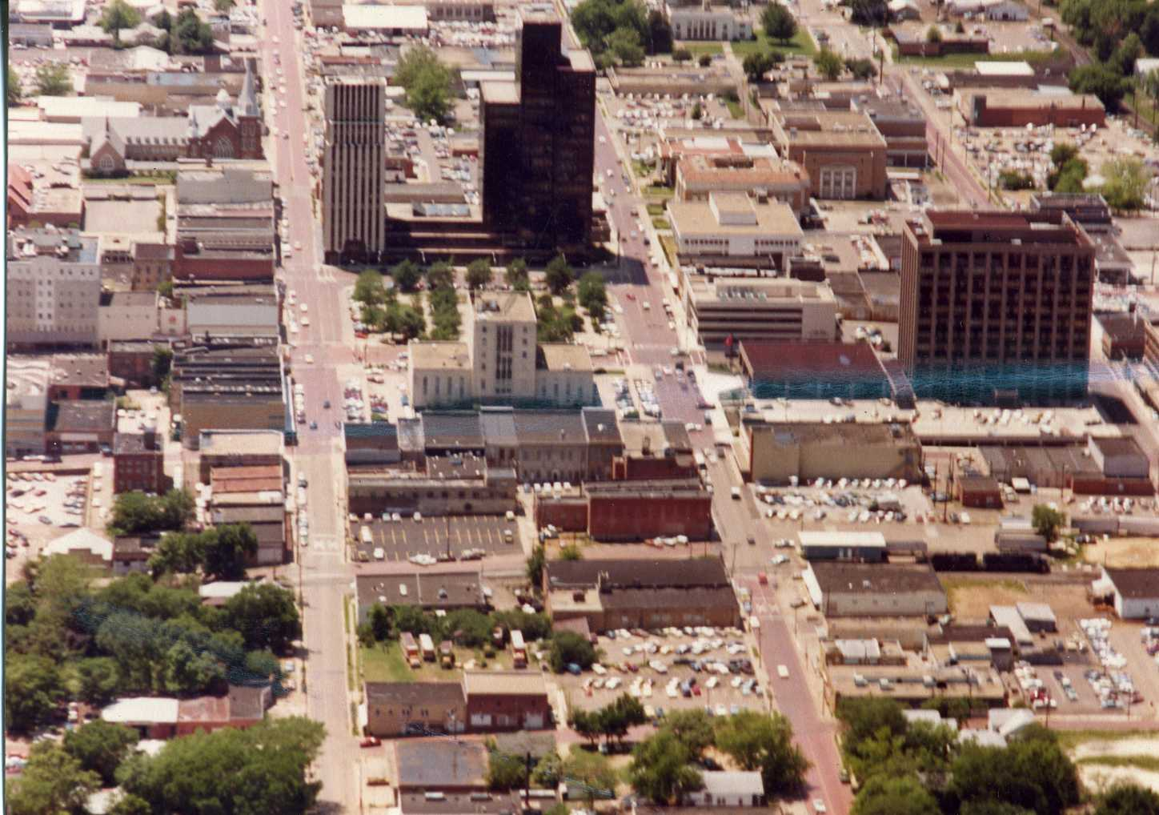AERIAL
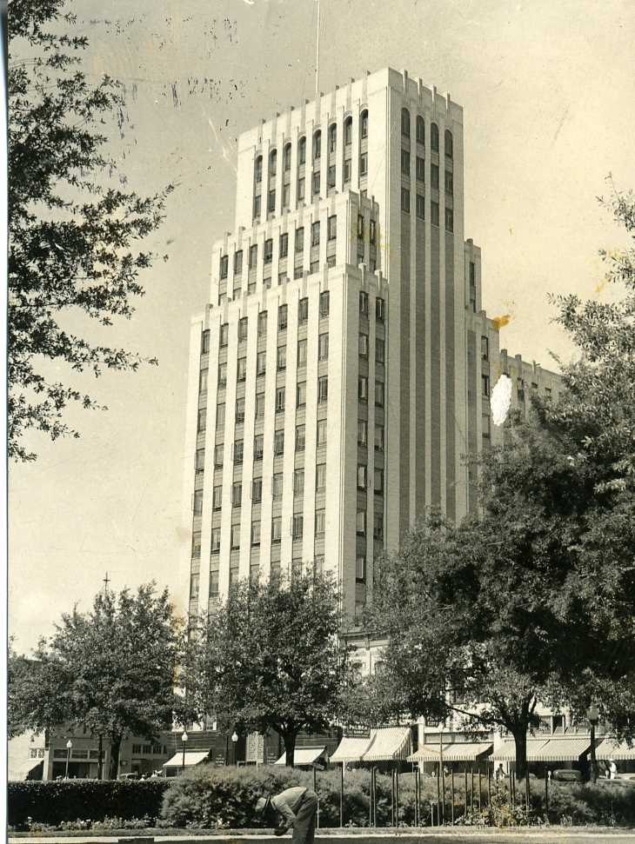BUILDINGS
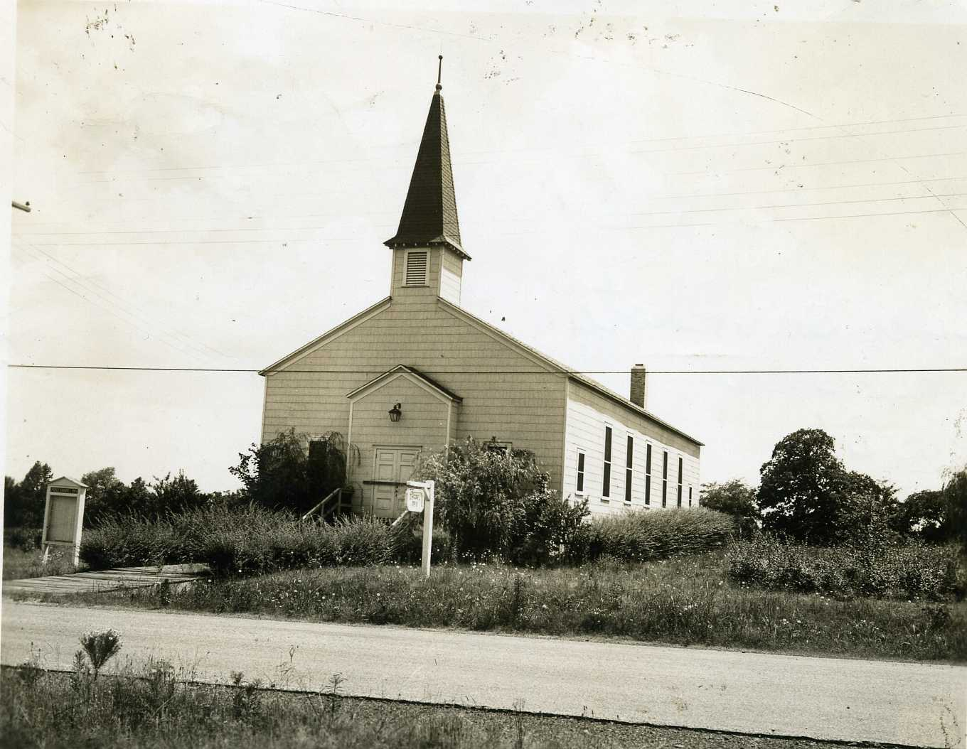Churches
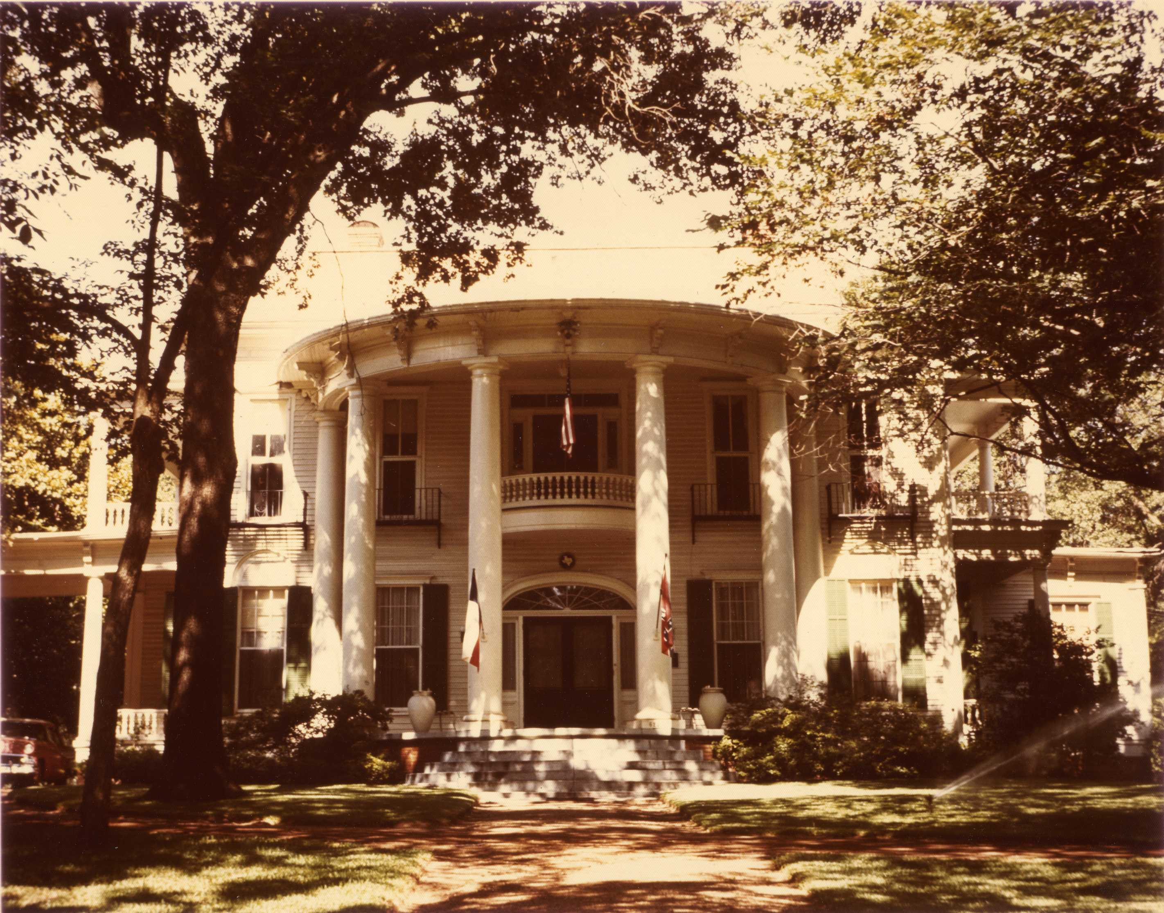Houses
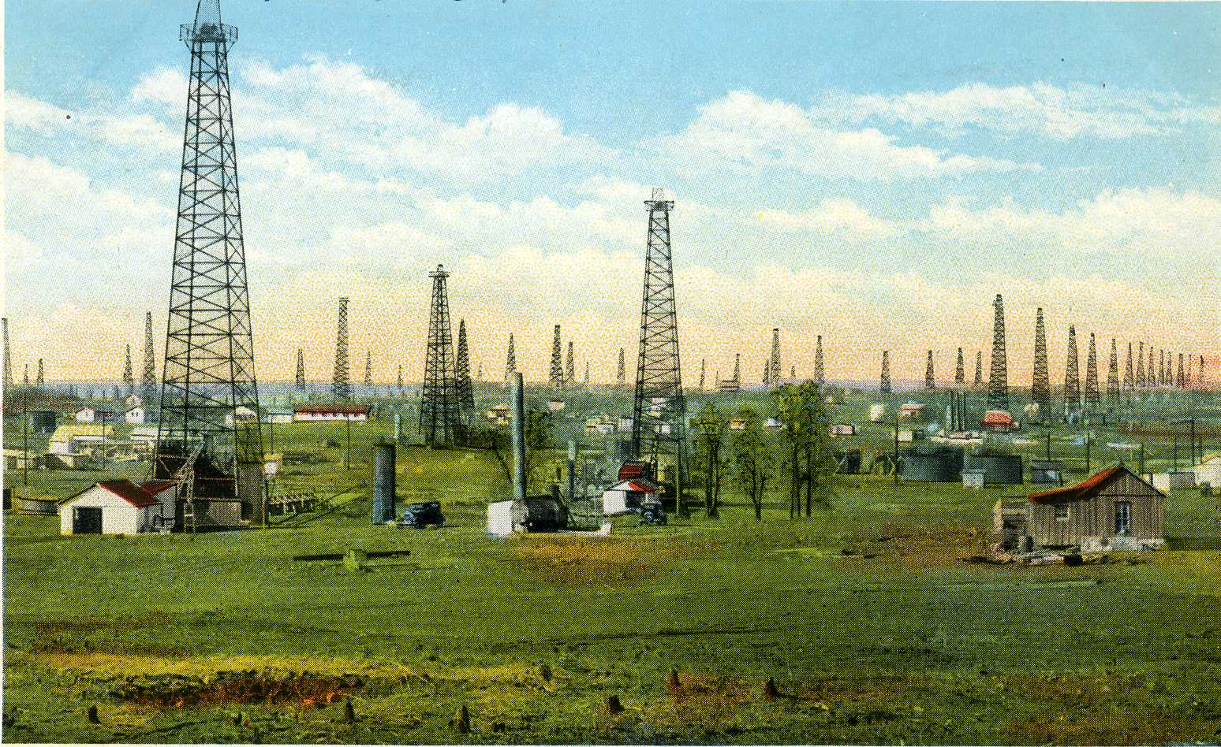Oil
……Just to name a very few
Photo
Collection
Covers
a wide
range
of topics>
and
time periods:

The Smith County Historical Society has been
collecting photographs, negatives, tin types
and all other forms of imagery since 1959.
The oldest identified photos in our
Collection go back to the 1870s showing
downtown Tyler from the J.P. Douglas
Collection. Other notable collections to
mention are:

Falkner 1950s-80s, every subject imaginable
Is covered
Chamber of Commerce 1930s-60s, businesses
And events
Nichols 1940s-early60s weddings and portraits
Delk 1970s-2010 official photography of the
Texas Rose Festival, schools and weddings
Tyler Star 1930’s-70s newspaper copy and
Advertisement photos

The archives also has panoramic pictures,
family collections, school collections,
postcards, and newspapers. All copies of
images can be made on site. Please call
or email or more information:
903-592-5993
archives@smithcountyhistoricalsociety.org

